## **Software Engineering Process**

**SOEN 6011**

Summer 2016

Group 6

**Prepared by:**

Vivek Khatri 27292848

Navneet Kaur 27676638

Sarvenaz Khaksarfard 40002880

Pardeep Kaur 40014804

Muhammad Raza Khan 27735987

Neha Kumari 27382073

Ankit Lathia 27378327

Mitesh Kaura 27284756

## Project scope

This project is intended to develop a desktop and mobile application for Tic TAC Toe game. We would be developing 3 elementary applications to support desktop and android platforms. These are elementary applications for the game, which would support both, single player (vs. CPU) and multiplayer gaming. The project is intended to increase our understanding of software engineering processes during the whole development process and the final products are not intended to be marketed.

## Objectives

Our main objectives for the project is to create 3 deliverables of TIC TAC TOE game, along with proper documentation containing of 5 supporting documents which includes the project plan, Requirements document, Domain Model, Test Report and State Diagram.

Deliverable 1 is a desktop application supporting a multiplayer version of the game.

Whereas, deliverable 2 is the same application as deliverable 1, but with support for Android platform.

Finally, Deliverable 3 would be using different heuristics to make the application support single player gaming against computer with different levels of difficulty.

## Project Constraint

We prefer to follow an iterative and incremental process for the development, making it more as a unified process with focus on process adaptability and customer satisfaction; since we have deadlines for each deliverable in gap of 1 week.

The application requires a PC with Java Support or an Android mobile/tablet with a minimum RAM of 128 MB.

The skill set of programmers for Android platform in our team is limited. The exposure to Java swing is yet another domain in which we do not possess expertise.

## Project Assumptions

We assume that the user tends to have basic knowledge of using Desktop/Laptop and Android mobiles/tablets.

Although, we would be adding a tab explaining the rules of the game, we assume that the user has prior experience or understating of playing TIC TAC TOE.

If the first click on the board is “**X**” then the other input on the board should be “**O**” and vice versa.

User should be allowed to reset or close the game window and proper acknowledgement should be received by the player.`

# Project Plan

## Team Organization

|  |  |  |  |
| --- | --- | --- | --- |
| Name | Student ID | Team Roles | Responsibilities |
| Vivek Khatri | 27292848 | Project Manager | * Managing the team * Working on creating project plans and schedules * Documenting and designing |
| Sarvenaz Khaksarfard | 40002880 | Documentation Lead | * Documenting and designing * Managing people working on documentation * Working on creating final plans and documents |
| Pardeep Kaur | 40014804 | Systems Engineer | * Gathering Requirements * Designing * Testing |
| Muhammad Raza Khan | 27735987 | Developer | * Working on Eclipse Plugin * Programming * Work on the API |
| Navneet Kaur | 27676638 | Testing Lead | * Managing the Testers * Testing * Editing Documents |
| Neha Kumari | 27382073 | Designer and Tester | * Documenting * Testing * Designing |
| Ankit Lathia | 27378327 | Programming Lead | * Programming * Work On API * Managing the programmers |
| Mitesh Kaura | 27284756 | Developer and Tester | * Programming * Testing * Working on API |

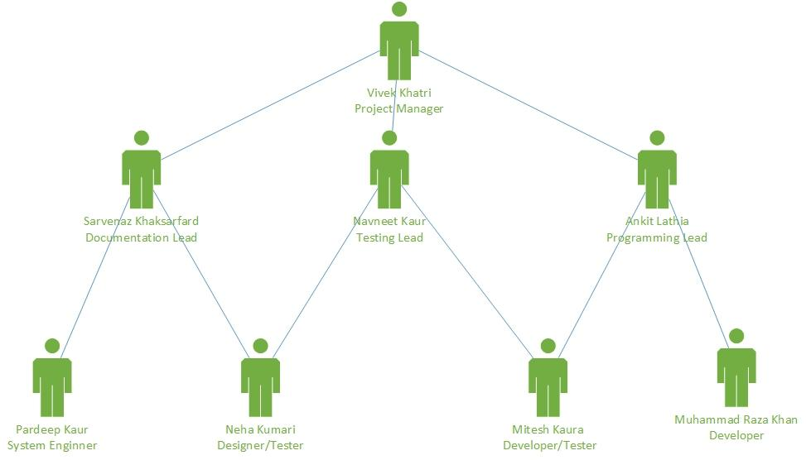

*Figure 1.Team Member's roles*

Work Breakdown Structure and Gantt Chart

The figures below illustrates the time and effort required for the work breakdown structure and Gantt charts shows the commonly used tasks for tracking project schedules. Gantt chart below show additional information about the various tasks or phases of the project, for example how the tasks are related to each other, how far each task has progressed, what resources are being used for each task and so on.

## Work Breakdown Structure

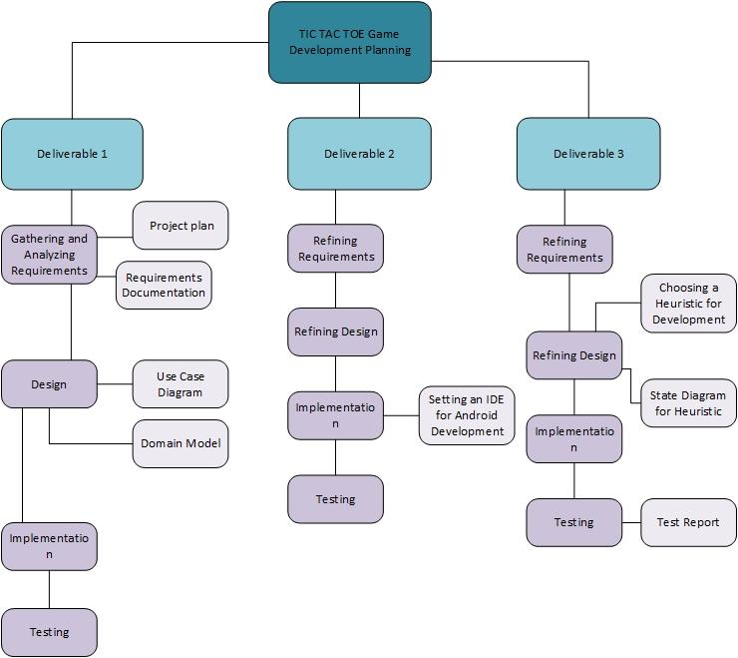

*Figure 2. Work Breakdown Structure*

## Gantt Chart

